A report on the analysis of the N-body programs with
MPI version and OpenMP version

Bo CHEN
School of Computer Science
The University of Adelaide
Australia
Email: bo.chen@student.adelaide.edu.au

1 The implementation
  - Implementation of MPI version
The basic idea is data parallelism, that is different particles are processed on different processors. For example, there are N particles and numProcs processors involved in computing. All particles are evenly distributed to every processor such that each processor is responsible for computing N/numProcs particles.

This model is ideal for the case N%numProcs equals 0, which means there are no superfluous particles. Unfortunately, in most cases, the value N%numProcs is not equal to 0. The approach adopted in this implementation to deal with this situation is that each processor will compute one more particle, except the last processor, once N%numProcs is not equal to 0. For instance, N is 999, and numProcs is 10, and then each processor will compute (N/numProcs + 1) = 100 particles, while the last processor process the remaining particles, which is 99 particles for the last processor. It ensures that at most one more computation is needed, while some other approaches require more computation time, such as computing all the superfluous particles in the master(0) processor, which requires N%numProcs computation time. Obviously, the former implementation is more efficient, since the N%numProcs computation time becomes bottleneck in the latter implementation.

Each processor computes its start index and end index in the whole particles array (x) and the relevant displacement array, which is used to gather processed particles to the master processor. This should be done before the loop function update( ), since these values are fixed during the execution, and no need to be re-computed.

In the functions update() and update(), particles in the array x are computed in parallel. For example, N is 999, and numProcs is 10, then processor 0 will computer x[0] to x[99], and processor 1 will computer x[100] to x[199]. As mentioned the indices of x have been computed before the update() loop to reduce the repeated works. After the particles’ positions have been renewed in each processor, the master processor (0) will gather all the new data in each processor, and store to x array. The master processor will re-distribute all the new particles to every processor in the next time step.

The data parallelism in computing the average distance is similar to the above approach, in which each processor compute part of the distance, except the last processor. The last processor will do less work.

1.2 Implementation of OpenMP version
The implementation is also based on data parallelism, in which different particles are updated by different threads. How the all particles are partitioned is not explicitly specified, except the init() function, in which static schedule is adopted. It means that the partition of particles in others function may be static or dynamic.

In the update() function, there are two ‘for’ loops to be paralleled. One is updating the total force for every particle, and the other is updating the positions of the particles. Note that the whole array x can be shared.

  - Implementation of task farm with MPI version
The basic idea is setting the processor (0) as master processor, which is responsible for distributing the tasks and gathering the result from other processors. A task is processing a new N number of particles; therefore the difference between tasks is the number of particles. Each processor except the master processor will update the particles with sequential version of the routine. Note, in this implementation, all the tasks use the same time steps; hence the program will broadcast the time steps before any processor is executed.

The typical procedure is as follow:
- Master processor (0) reads the number of tasks and each number of particles.
- Master processor blocks in receiving message, and determines whether the message is requesting for a new task or returning the processed result.
- Master processor will terminate after each task has been completed AND each other processor has terminated.
- Each available other processor sends message to request a new task, and it determines if the message is informing no task needed to be processed or containing the valid data. If there is no task needed to be processed, this processor will terminate, or it will execute the routine with sequential version, and return the result to master processor finally.

  - Implementation of task farm with OpenMP version
The principle of this implementation is that the tasks are executed in different threads with sequential version of the routine. Tasks in the task farm are the same as MPI version.

Before parallelize the execution, the program reads the number of tasks and each number of particles for each task. After that, the tasks are put into a ‘for’ loop, and this loop is parallelized.

- The analysis of performance
2.1 Methodologies
To measure the performance of programs run on multi-processors and programs run with multi threads, the results of a wide range of running time will be gathered and analyzed. It includes:
- Analysis of the result for speedups and efficiencies for different numbers of processors.
- Analysis of the result for speedups and efficiencies for different number of particles (N values).
- Analysis of the different performance in using OpenMP (2 threads) and MPI (2 processors).
- Analysis of the difference of execution time in using task farm with MPI version and the MPI version with data parallelism.

The execution time is measured in between the first init() and the end of the program. To get the reasonable execution time, the nodes containing other users’ processes are excluded, and each program is launched 5 times to get the average execution time.

  - Benchmark results and the analysis
A group of N values are tested for different number of processors: N=100, 1000, 5000, 10000, and the time steps is 100. The execution time is measured in seconds. Table 1 shows the benchmark results:

Num of procs  N particles | 1 | 2 | 3 | 4 | 5 | 6
100 | 0.087 | 0.397 | 0.375 | 0.715 | 0.771 | 0.776
500 | 2.057 | 1.512 | 1.240 | 1.274 | 1.177 | 1.151
1000 | 8.420 | 4.709 | 3.524 | 3.031 | 2.818 | 2.567
5000 | 204.251 | 103.746 | 70.677 | 53.815 | 44.159 | 39.508
Table 1: The execution time with different number of processors
and problem sizes

2.21 Analysis of the data row by row (with different number of processors):

Case 1: computation time is relatively smaller than communication time.
It is interesting to see that the execution time significantly increases with the increase of the number of processors. This is one of the cases that the performance of multiple processors is even worse than single processor. The reason is fairly straightforward, that there are only 100 particles (N = 100), for which the computation time in a single processor is very fast (0.087 second in the above case). When adding more processors, the communication time which is quite large compared with computation time, dominates the performance of the calculation. The Figure 1 below shows the change:
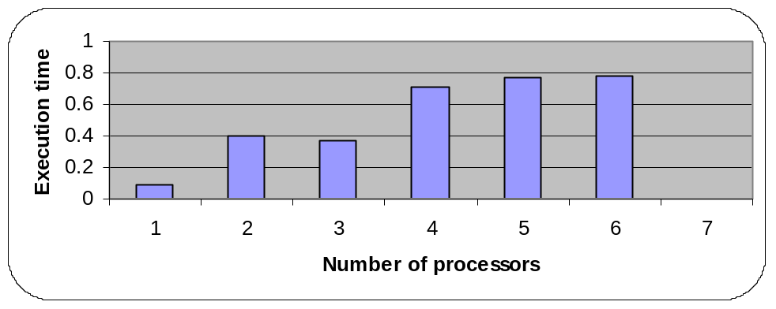
Figure 1: Change of the execution time when N = 100

Case 2: computation time is larger than communication time. The performance of programs with multiple processors gets improved with increasing the number of particles (500, 1000 and 5000). Notice that, when the number of processors is increased from 1 to 2 processors, the execution time drops greatly, while continuing adding more processors, the execution time declines with smaller and smaller degree. This is caused by the rise of communication time. As the above table shows, when the number of processors increased from 5 to 6 processors, the performance is just little improved. As the Figure 2 shows:

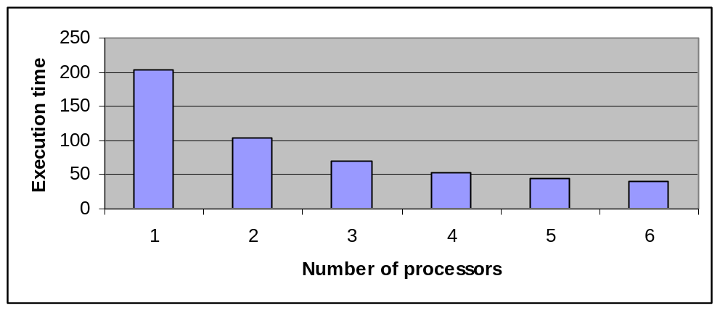
Figure 2: Change of the execution time when N = 5000

Figure 3 gives the change of speedups. Speedup = ts / tp, where ts is the execution time for sequential version of the program and the tp is the execution time of parallel version.

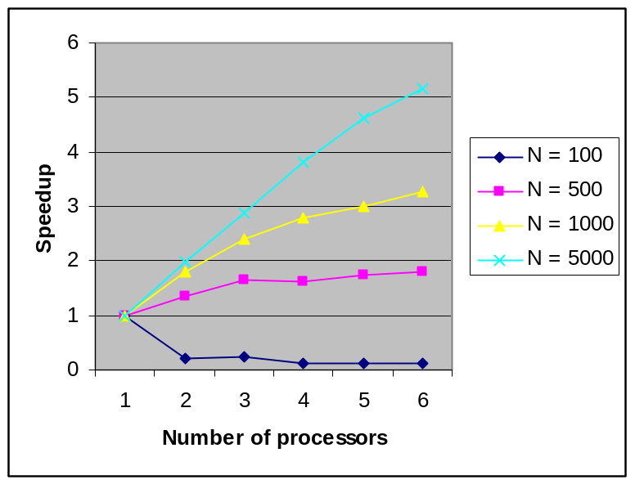
Figure 3: The speedups for programs with different number of processors
and problem sizes.

This chart shows many interesting features of multiple processors program.

Firstly, as mentioned above, when N is small (say, 100), the performance is even worse with the increase of processors. This is shown in the chart that, the speedup is decrease for N = 100.

Secondly, the speedup is higher with higher number of particles (N values). With increasing the number of processors, the rates of speedup slow down. Moreover, notice that the growth in speedup for the programs with lower N values (e.g. N = 500) tend to smooth, while the program with high N value (e.g. N = 5000) increases the speedup more sharply.

The reason is that with higher N value, the computation time holds larger proportion in the execution time than the programs with lower N values. Hence, while increasing the number of processors, the communication time have more influence on the program with lower computation time.

The figure 4 shows the efficiencies of the programs.
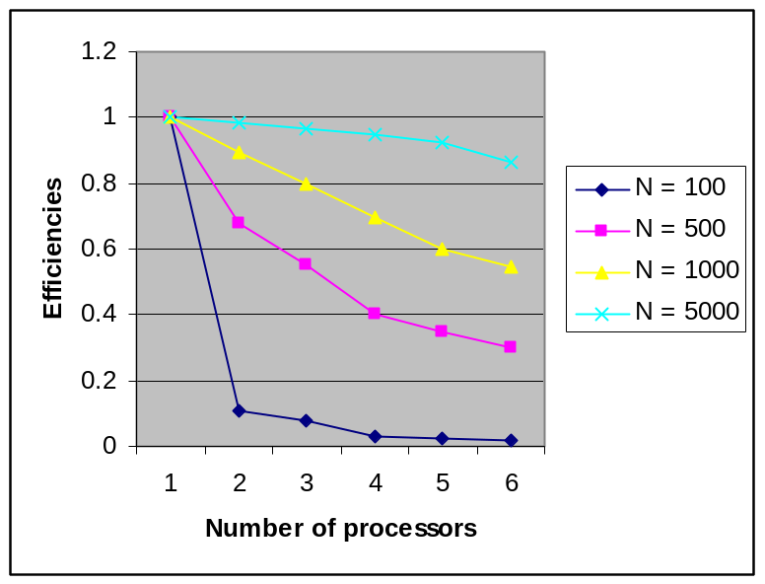
Figure 4: the efficiencies for programs with different number of processors
and problem sizes.

It is clear that the efficiencies decline more rapidly with programs that have lower problem sizes (e.g. 100, and 500). This confirms the observation in the speedup chart, that the communication time has more impact for the programs that have lower computation time.

The other observation is that the efficiencies in all programs decline with the same problem size and increase of processors number. The reason is that communication time holds more and more proportion in the whole execution time when the number of processors rises, and in the meantime, the computation time is the same due to the fixed problem sizes.

2.22: Analysis of the data row by row (with different problem sizes: N values):
As the tables show, the execution times go up rapidly with increase of problem sizes. This is because of the time complexity of computation is O(N^2). While the N rises from 1000 to 5000, the computation time will increase by (5000/1000)^2 times, that is 25 times. Hence, the execution time increases from around 8.4 seconds to 205 seconds when the number of processor is 1.

2.23: Differences in results in using MPI and OpenMP.
Since there are max 2 threads can be run simultaneously in the OpenMP in the lab, the comparison will be performed between MPI version program with 2 processors and OpenMP version program with 2 threads.

The table 2 below shows the results of running program with different problem size (from 100 to 5000) and the same time steps (100):

Program type  N particles | MPI  (2 processors) | OpemMP  (2 threads)
100 | 0.397 | 0.051
500 | 1.512 | 1.057
1000 | 4.709 | 4.037
5000 | 103.746 | 98.637

Table 2 : the result of programs of MPI version and OpenMP version with different problem sizes.

It can be seen that for the smaller problem sizes, e.g. 100, the OpenMP version (0.051 second execution time) performances much better than MPI version (0.397 second execution time).

However, the advantages of OpenMP version become smaller with increasing the problem sizes (N values). When N = 5000, the performances of MPI version (103.7 seconds execution time) and OpenMP (98.6 seconds execution time) version nearly the same.

The differences in execution time are mostly caused by the communication time. Since the OpenMP is based on share memory, the threads can exchanges data in the shared memory with high speed, while the messages exchange in the MPI are much slower than OpenMP. The messages passing might be through Ethernet, in which the data transfer is much slower than in share memory. However, when the problem sizes are large, e.g. 5000 in the above example, the computation time dominates the performance of programs. Hence, the difference in the communication time (data exchange) between the two versions becomes more subtle.

Obliviously, the OpenMP version program always performances better than MPI version. But the costs for hardware are also higher then the MPI version programs. Therefore, there is a payoff in choosing these two versions.

- Approaches to improve the efficiencies of parallel programs
3.1 Approaches used in the MPI version
The principle of improving the performance of parallel programs with MPI implementation is keep each CPU busy in doing calculations.
In this program, as mentioned in the section 1.1, the assignment of number of particles that each processor should processes must be carefully dealt with.
To reduce the communication time, MPI_Gatherv() function is used, instead of using MPI_Send and MPI_Recv.

3.2 Load balance controls in the task farm MPI version.
A straightforward approach to improve the program with task farm MPI version is that, the tasks with higher problem sizes (N values) should be processed prior to the tasks with lower problem sizes. If the problems with higher problem sizes are processed later, others processors might be waiting for longer time to finish while there is no task.

4. Conclusion
The parallel computing can greatly improve the performances of programs, however, the communication time have significant impact in the performance. The performance gets worse when the communication time is large. Hence, every parallel program should be carefully designed to deal with the impact of communication time.

